***1) CREATING A DATABASE:***

package net.codejava;

import java.sql.*;

import java.sql.Connection;

import java.sql.DatabaseMetaData;

import java.sql.DriverManager;

import java.sql.ResultSet;

import java.sql.SQLException;

public class SQLiteMuleSoft {

public static void createNewDatabase(String filename) {

String url = "jdbc:sqlite:/D:\\6th SEM\\sqlite-tools-win32-x86-3380000"+filename;

try {

Connection conn = DriverManager.getConnection(url);

if (conn != null) {

DatabaseMetaData meta = conn.getMetaData();

System.out.println("The driver name is " + meta.getDriverName());

System.out.println("A new database has been created.");

}

} catch (SQLException e) {

System.out.println(e.getMessage());

}

}

public static void main(String[] args) {

// TODO Auto-generated method stub

createNewDatabase("Movies.db");

}

}

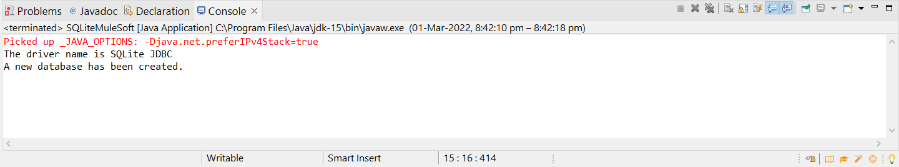

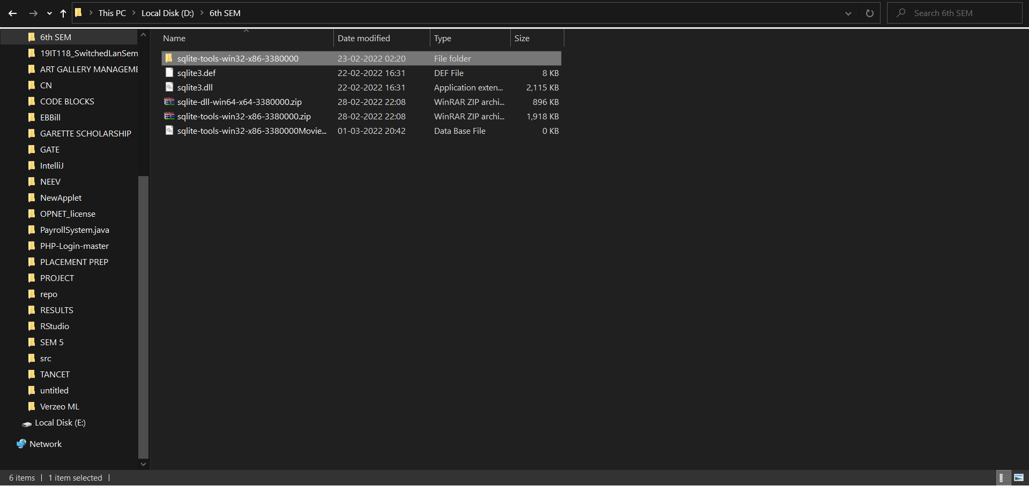

***2) CREATING TABLE:***

package net.codejava;

import java.sql.*;

import java.sql.Connection;

import java.sql.DatabaseMetaData;

import java.sql.DriverManager;

import java.sql.SQLException;

public class SQLiteMuleSoft {

public static void createNewTable() {

String url = "jdbc:sqlite:/D:\\6th SEM\\sqlite-tools-win32-x86-3380000\\Movies.db";

String sql = "create table MuleSoftmovies(id int primary key,"

+ "name varchar(20), actor varchar(20),actress varchar(20),year int, director varchar(20))";

try{

Connection conn = DriverManager.getConnection(url);

Statement stmt = conn.createStatement();

boolean b=stmt.execute(sql);

System.out.println("Table Created Successfully");

} catch (SQLException e) {

System.out.println(e.getMessage());

}

}

public static void main(String[] args) {

// TODO Auto-generated method stub

createNewTable();

}

}

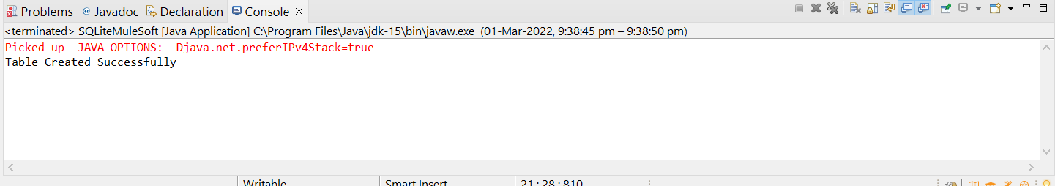

***3. INSERTION OF RECORDS:***  
package net.codejava;

import java.sql.Connection;

import java.sql.DriverManager;

import java.sql.PreparedStatement;

import java.sql.SQLException;

public class SQLiteMuleSoft {

private Connection connect() {

// SQLite connection string

String url = "jdbc:sqlite:D://6th SEM/sqlite-tools-win32-x86-3380000/Movies.db";

Connection conn = null;

try {

conn = DriverManager.getConnection(url);

} catch (SQLException e) {

System.out.println(e.getMessage());

}

return conn;

}

public void insert(int id,String name, String actor,String actress, int year, String director) {

String sql = "INSERT INTO MuleSoftmovies(id,name,actor,actress,year,director) VALUES(?,?,?,?,?,?)";

try{

Connection conn = this.connect();

PreparedStatement pstmt = conn.prepareStatement(sql);

pstmt.setInt(1,id);

pstmt.setString(2, name);

pstmt.setString(3,actor);

pstmt.setString(4,actress);

pstmt.setInt(5,year);

pstmt.setString(6,director);

pstmt.executeUpdate();

System.out.println("Inserted the records");

} catch (SQLException e) {

System.out.println(e.getMessage());

}

}

public static void main(String[] args) {

SQLiteMuleSoft app = new SQLiteMuleSoft();

// insert three new rows

app.insert(4,"Avengers", "RDJ","Scarlett",2019,"Shawn");

app.insert(5,"Spiderman No way Home","Tom Holland","Zendaya",2020,"Rick Riordan");

app.insert(6,"Twilight","Robert Pattinson","Kristen Stewart ",2008,"Annabelle");

}

}

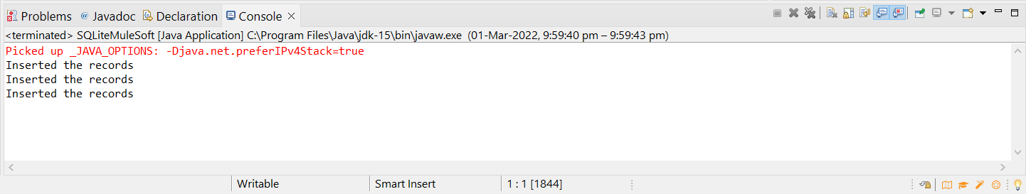

***4) RETRIEVAL:***

package net.codejava;

import java.sql.DriverManager;

import java.sql.Connection;

import java.sql.ResultSet;

import java.sql.SQLException;

import java.sql.Statement;

public class SQLiteMuleSoft {

private Connection connect() {

// SQLite connection string

String url = "jdbc:sqlite:D://6th SEM/sqlite-tools-win32-x86-3380000/Movies.db";

Connection conn = null;

try {

conn = DriverManager.getConnection(url);

} catch (SQLException e) {

System.out.println(e.getMessage());

}

return conn;

}

public void selectAll(){

String sql = "SELECT * FROM MuleSoftmovies";

try {

Connection conn = this.connect();

Statement stmt = conn.createStatement();

ResultSet rs = stmt.executeQuery(sql);

// loop through the result set

while (rs.next()) {

System.out.println(rs.getInt("id") + "\t" +

rs.getString("name") + "\t" +

rs.getString("actor")+ "\t" +

rs.getString("actress") + "\t" +

rs.getInt("year") + "\t"+

rs.getString("director"));

}

} catch (SQLException e) {

System.out.println(e.getMessage());

}

}

public static void main(String[] args) {

SQLiteMuleSoft app = new SQLiteMuleSoft();

app.selectAll();

}

}

